**requestotp**

This API provides sent otp to mobile number.

|  |  |
| --- | --- |
| **Method** | POST |
| **URL** | https://uatutilities.plindia.com/apiutilities/api/guest/requestotp |
| **Request Type** | JSON |
| **Response Type** | JSON |

**Request format**

|  |  |  |
| --- | --- | --- |
| **Field** | **Type** | **Description** |
| application | string(10) | Application name |
| mobileno | string(10) | Mobile No |

**Responseformat**

|  |  |
| --- | --- |
| **Type** | **Description** |
| string(100) | OTP SENT SUCCESSFULLY / INVALID APPLIATION |

**Sample Request**

{"application":"APP1","mobileno":"9999999999"}

**Sample Response (for successful OTP)**

OTP SENT SUCCESSFULLY

**Sample Response (Application not found)**

INVALID APPLIATION

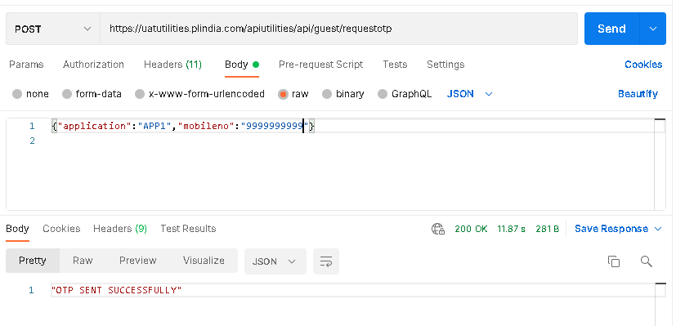

**Verifyotp**

This API verifies OTP.

|  |  |
| --- | --- |
| **Method** | POST |
| **URL** | https://uatutilities.plindia.com/apiutilities/api/guest/verifyotp |
| **Request Type** | JSON |
| **Response Type** | JSON |

**Request format**

|  |  |  |
| --- | --- | --- |
| **Field** | **Type** | **Description** |
| otp | int | otp |
| mobileno | string(10) | Mobile No |

**Responseformat**

|  |  |
| --- | --- |
| **Type** | **Description** |
| string(100) | VALIDOTP / INVALIDOTP / OTPEXPIRED |

**Sample Request**

{"otp":"475291","mobileno":"9999999999"}

**Sample Response (for successful OTP)**

VALIDOTP

**Sample Response (Invalid OTP)**

INVALIDOTP

**Sample Response (OTP Expired)**

OTPEXPIRED

